|  |  |
| --- | --- |
| Gone Sin MAL (Eat more pay less)  Project Specifications | Abstract  Gone Sin (going down from high places without making any own efforts)  By Bit Geeks |

Contents

1. Introduction 2

1.1 Team Members and roles 2

2. Type of users 3

3. Functional Requirements 3

3.1 Login 3

3.1.1 Continue As Customer 4

3.1.2 Continue As Restaurant 5

3.1.3 Continue As Admin 6

3.1 Customers 7

3.2 Restaurants 12

3.3 Administraors 18

4. Success Criteria 20

5. Content Plan 21

6. Site Map 21

6.1 Customer Side 21

6.2 Restaurant Side 22

6.3 Administrators Side 23

7. Marketing Plan 23

8. Site Maintenance 24

9. Security For Web Service (API) 24

10. Timeline 25

11. Technical Information 28

# Introduction

Gone Sin Mal is a mobile platform for all restaurants or food shops which allows them to host their information. Moreover, they can even use the coin system provided by the platform to promote the sales or attract the customers.

Customers can gain coins from the restaurants, which use this application, by eating and with those coins, they can use it back when they go and eat at any restaurants that use the application. The difference between this application and other ones is that our coin system is universal, which is any gain coins from one restaurant can be used for all of the restaurants (all of the restaurants that use our application). Additionally, customers can get special promotion coins given by restaurants, which can be only used on that particular restaurant.

As for the restaurant side, they will get many costumers since they will be giving promotion coins. For the benefit, they can refund those coins that are used by the customers so they don’t lose money by buying those coins and giving it to customers. Moreover, since the special promotion coins can be used only on the particular restaurant, the customers who got that promotion coins will sure come and eat at the restaurant. This promotion system is well suited for newly start-up restaurants.

By using this application, everyone will be in a win-win situation. (customers can get discount when they go and eat at the restaurants, restaurants get more customers by promoting through the application, developers get benefits by selling coins and special promotion packages)

## Team Members and roles

|  |  |  |
| --- | --- | --- |
| Name | Main Role | Secondary Role |
| Khant Ti Kyi | Project Manager | Tester, Video Editing |
| Min Thu Khant | Backend Programmer | Frontend Programmer, Design and System Analyst |
| Aung Phone Kyaw | Frontend Programmer | Tester |
| Su Pyae Thu Ya | Usability analyst | Tester |
| Myo Thiha Tun | Database (implement) | Tester |
| Yune Nadi Oo | Tester | Project Advisor |

# Type of users

* Customers - Customers who buy food or each from the restaurants
* Restaurants - Owners of the restaurants in this platform
* Platform owners (Administrators) - Who sell and refund coins to Restaurants

# Functional Requirements

## 3.1 Login

Users can login to the App via Facebook Account. After successful login user will be asked to choose the type of user they want to be.

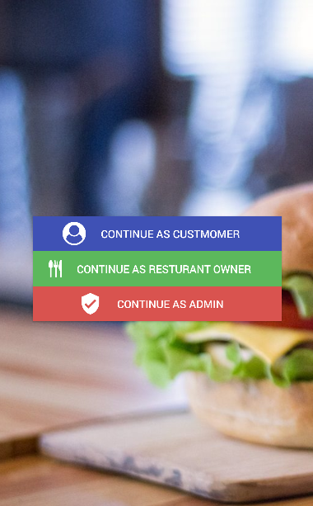

### 3.1.1 Continue As Customer

If the user clicked on “Continue as Customer” a map view will be shown and he/she will be asked pin point the location of his/her address. However, only state of the user will be stored. Home page of Customer will be shown after this phase.

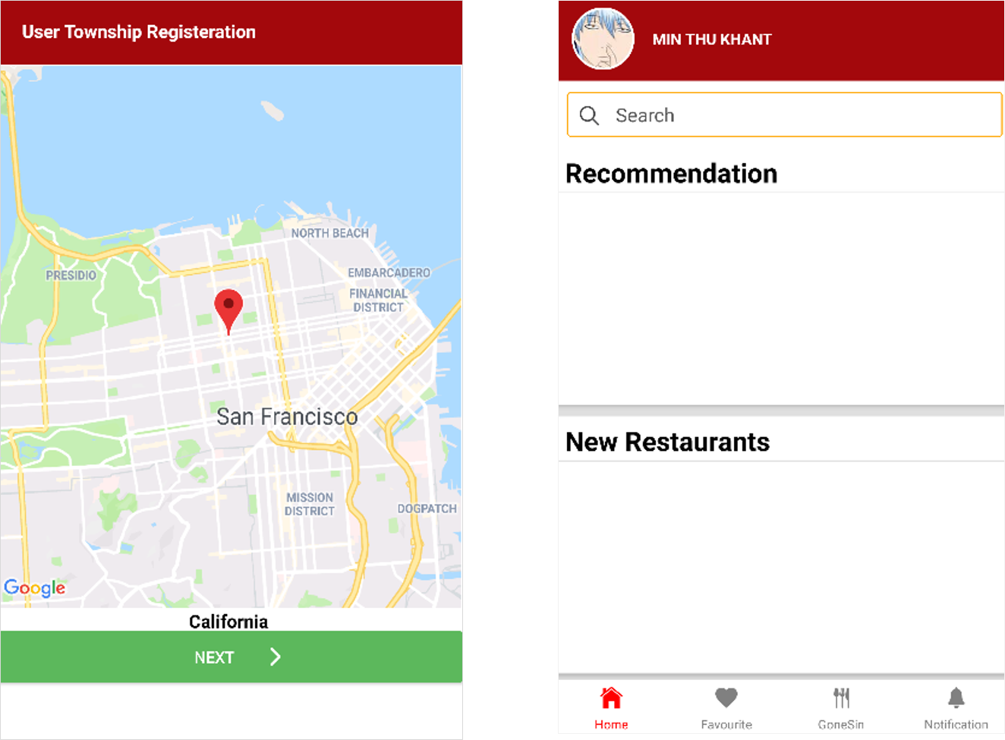

### 3.1.2 Continue As Restaurant

Register Page for the restaurant will be displayed if the user clicked on “Continue as restaurant”. Restaurant Home Page will be displayed after the Registration. In this page the user can fully customize the information of own restaurant.

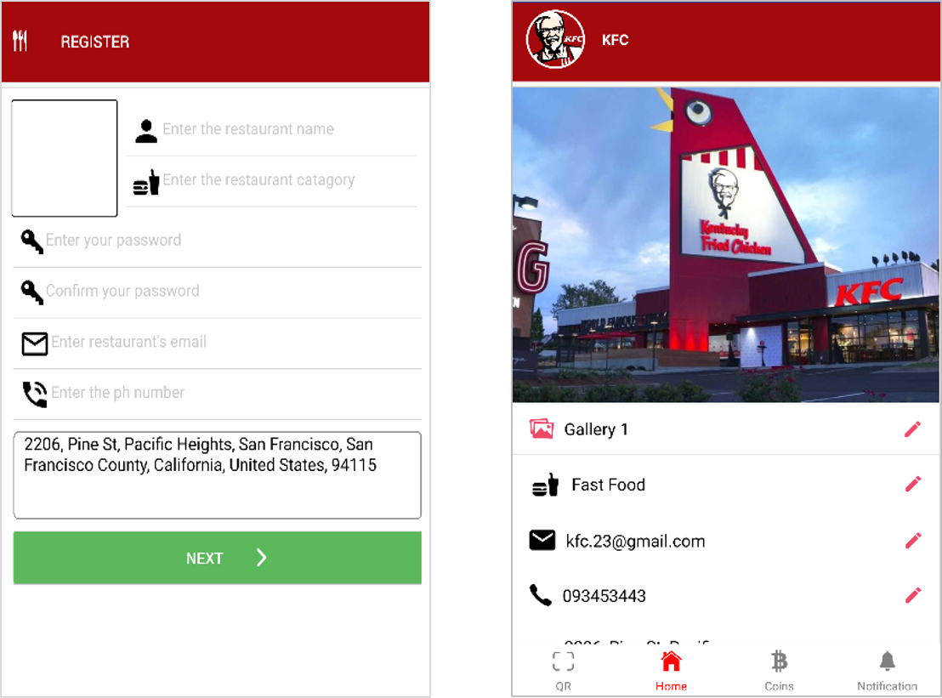

### 3.1.3 Continue As Admin

A modal will be shown to insert master key which is required to do gain access through admin tasks. Admin Home will be displayed if master key is correct.

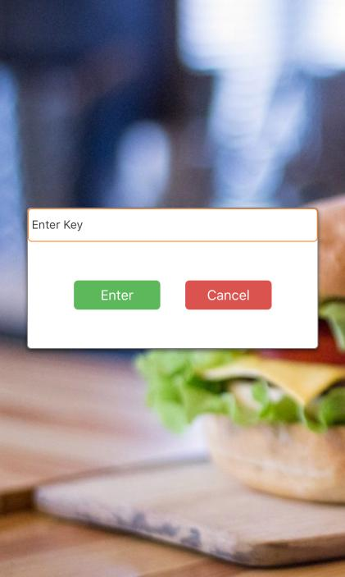

## 3.1 Customers

* Customer can able to see the list of registered restaurants sorted by Recommendation, and newly added and search bar.

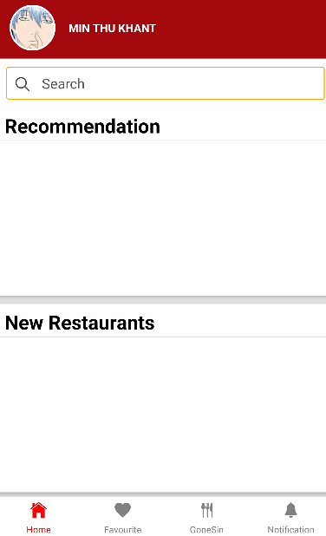

* Customer can able to see the profile which contains total coins, coins which are going to expire and QR code (for restaurants to scan when giving coins).
* Customer should be able to change the living location which is used by Application to send special offers.

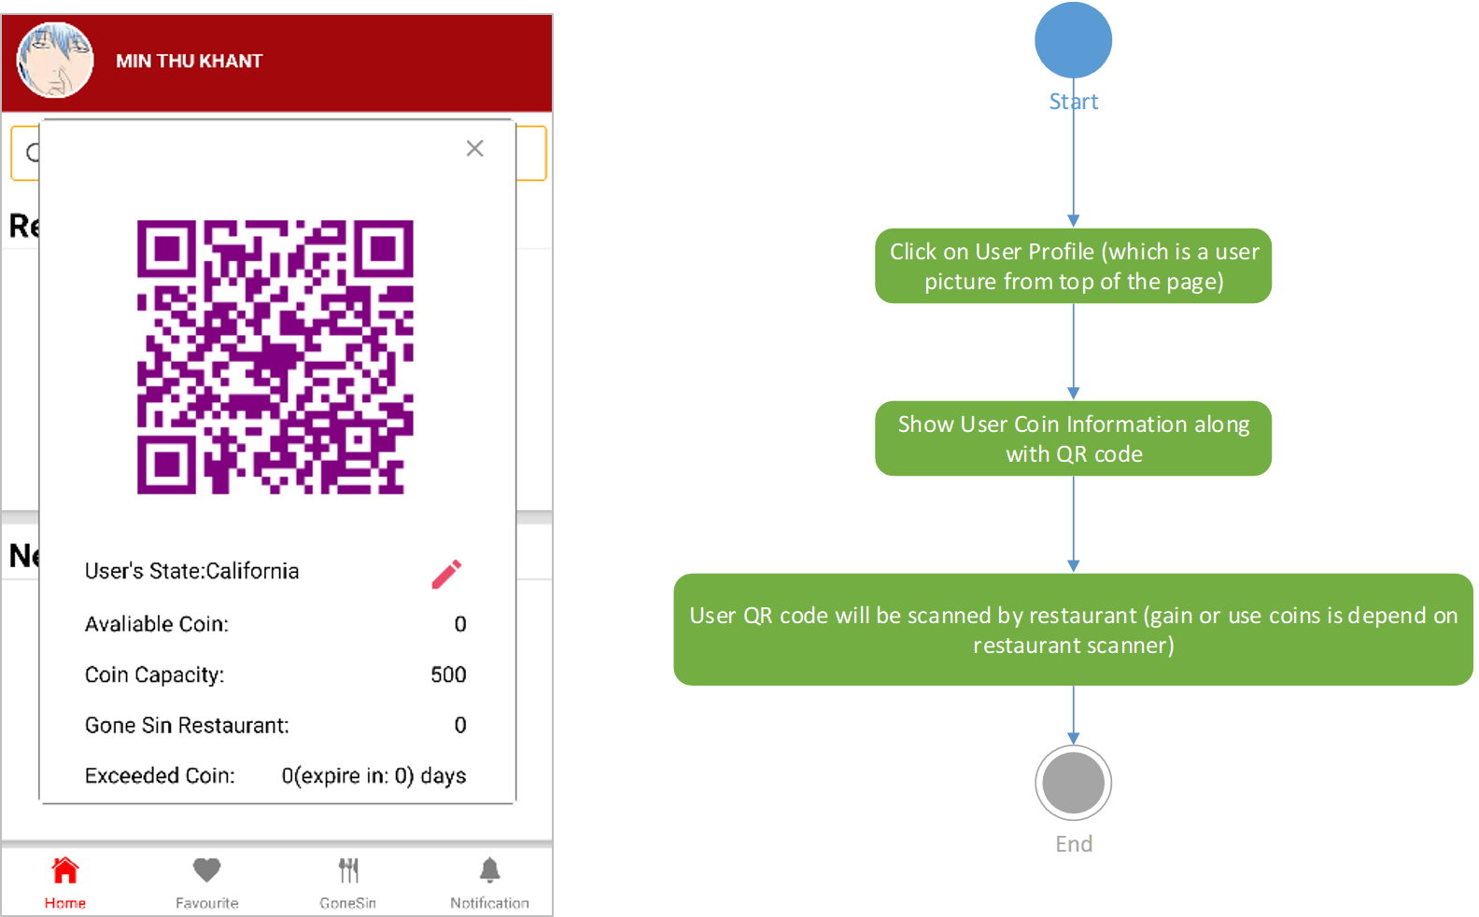

* Customer can able to see the special promotion coins and special restaurant.

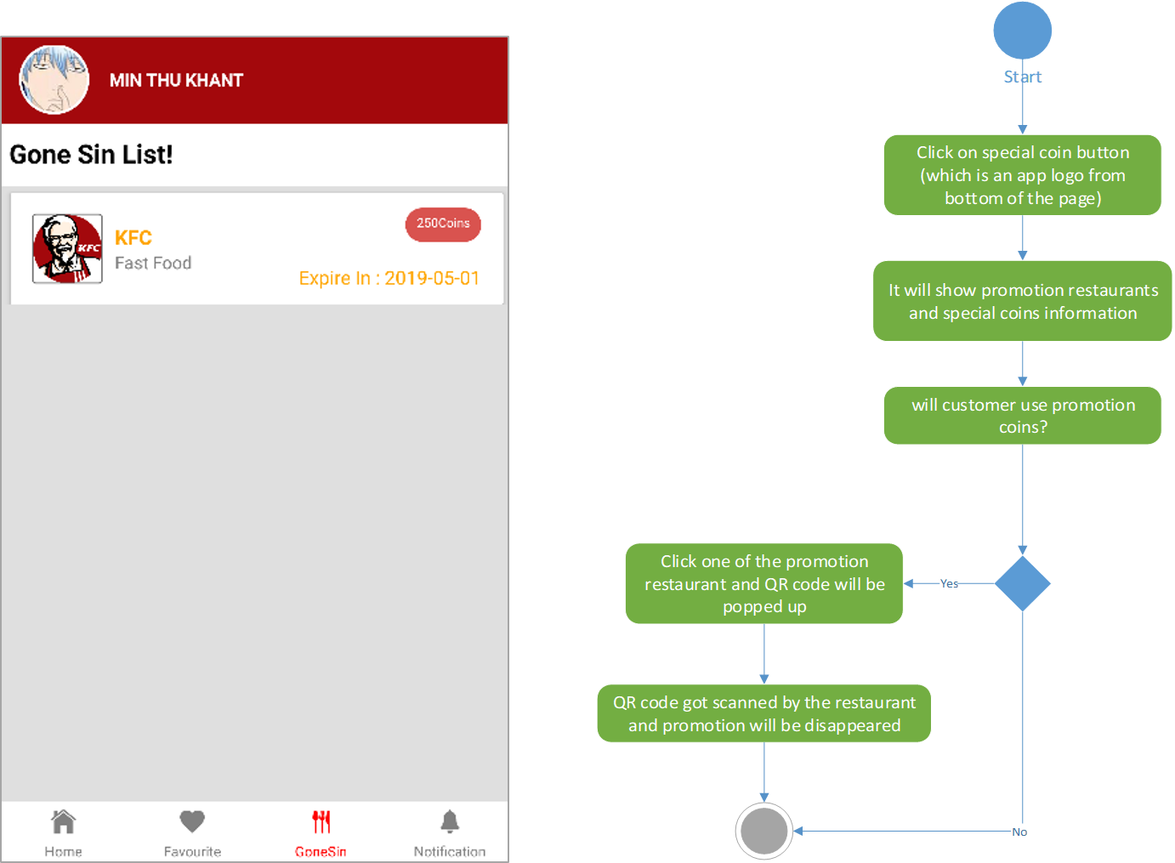

* A page to see the notifications (Example – “**$shope_name** give you **$coin_number** coins”, You have gained **“$coin_amount**” from **“$restaurant_name**”).

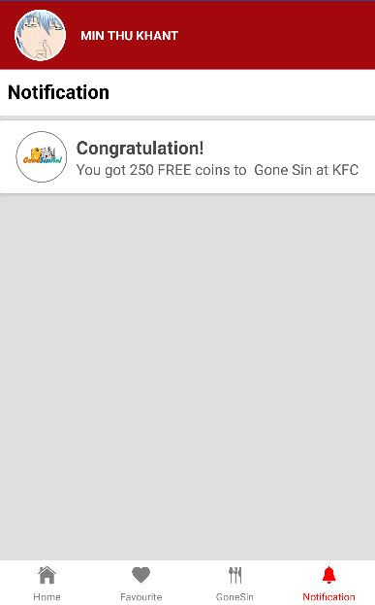

* A page that show a list of customer’s favorite restaurants.

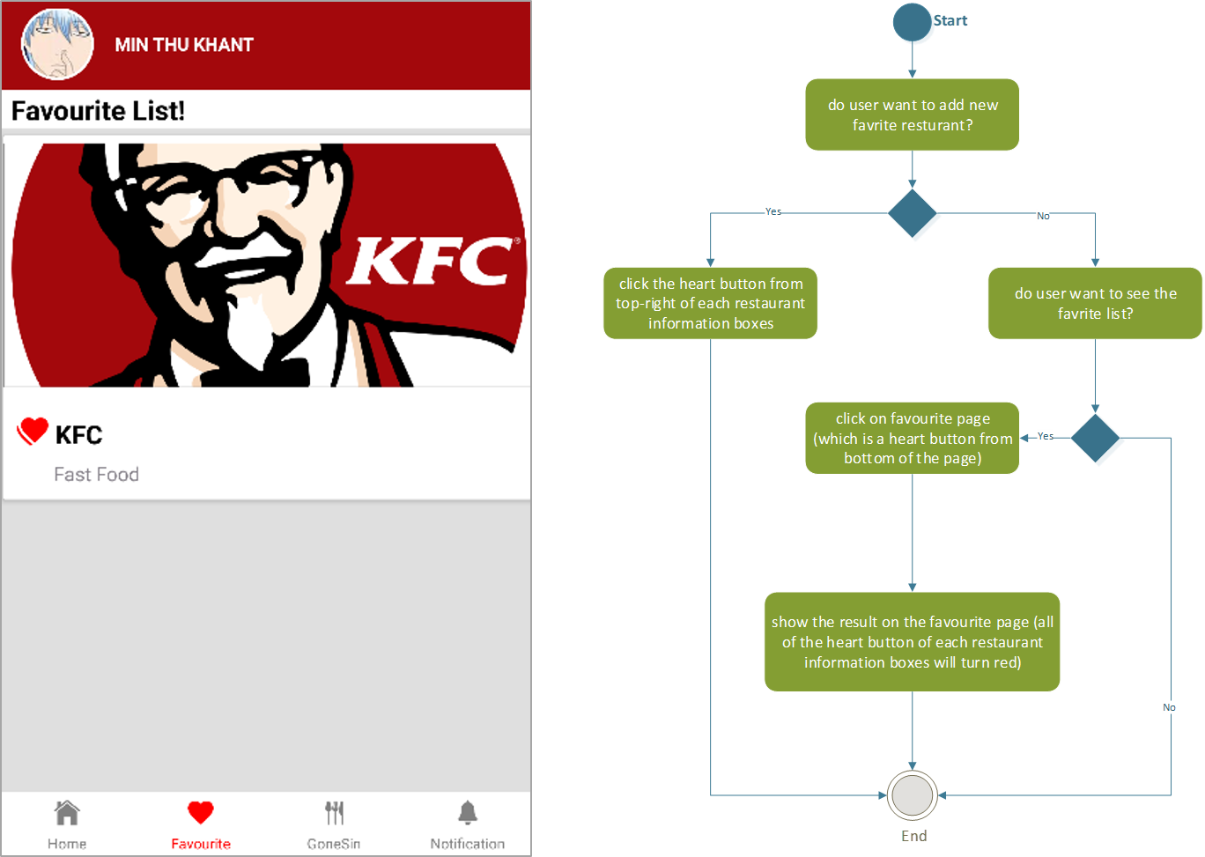

* A page to show detailed information about restaurant and map direction.

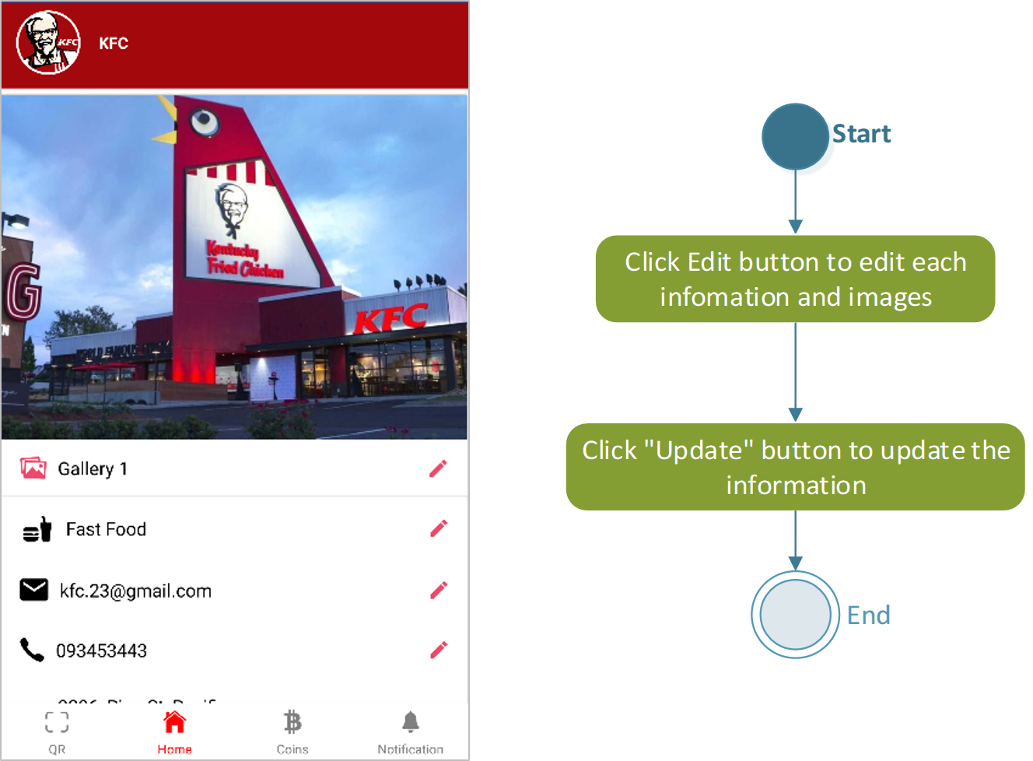

## Restaurants

* A QR code scanner which is used to pay or take coins by scanning the customer profile.

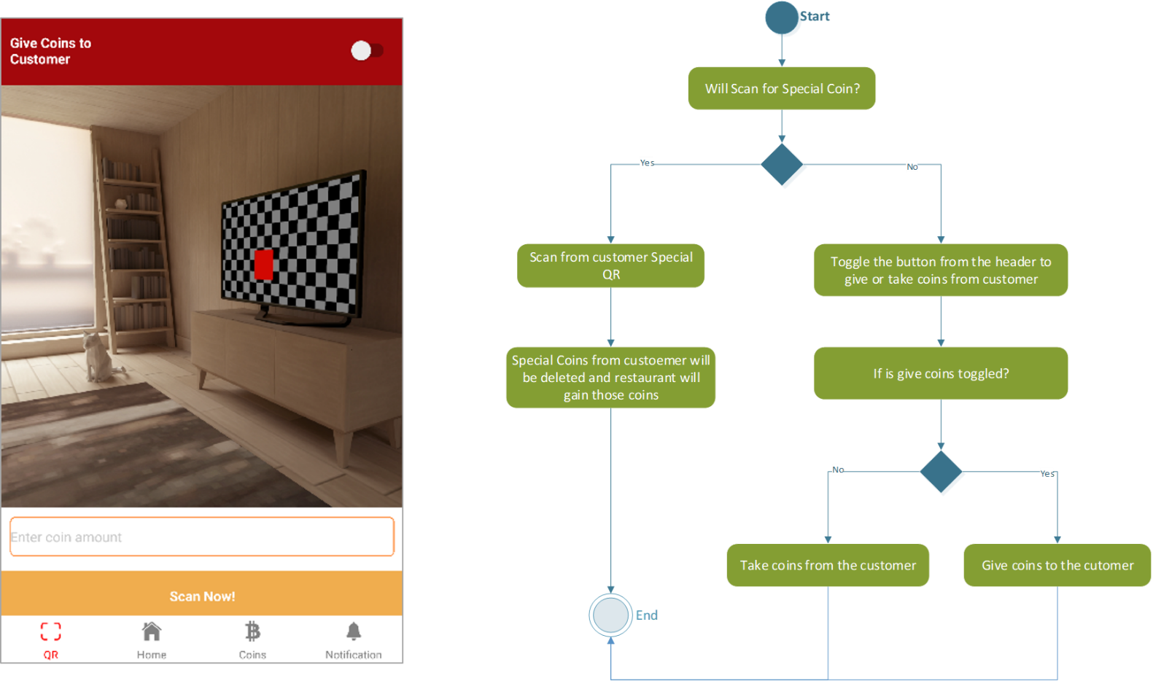

* A home page that shows available coins and special coins owned including coin buying/special coin buying options and function for refunding coins from the platform owner.

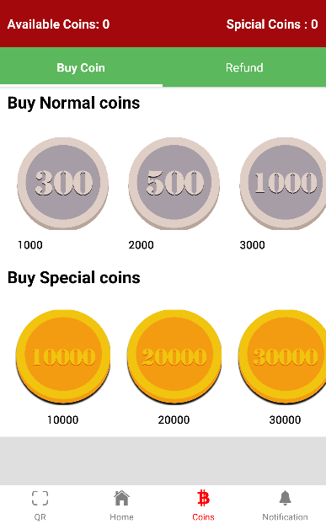



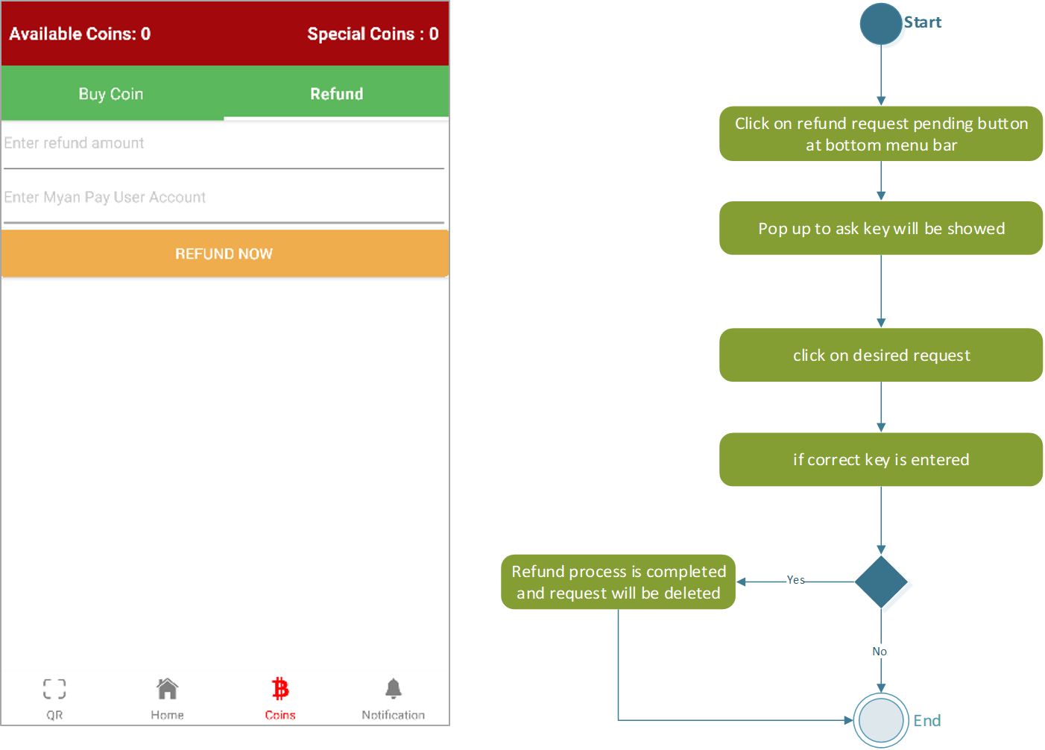

* Restaurant information can be modified as it required.



* A Page to confirm coin transaction process and view notification.

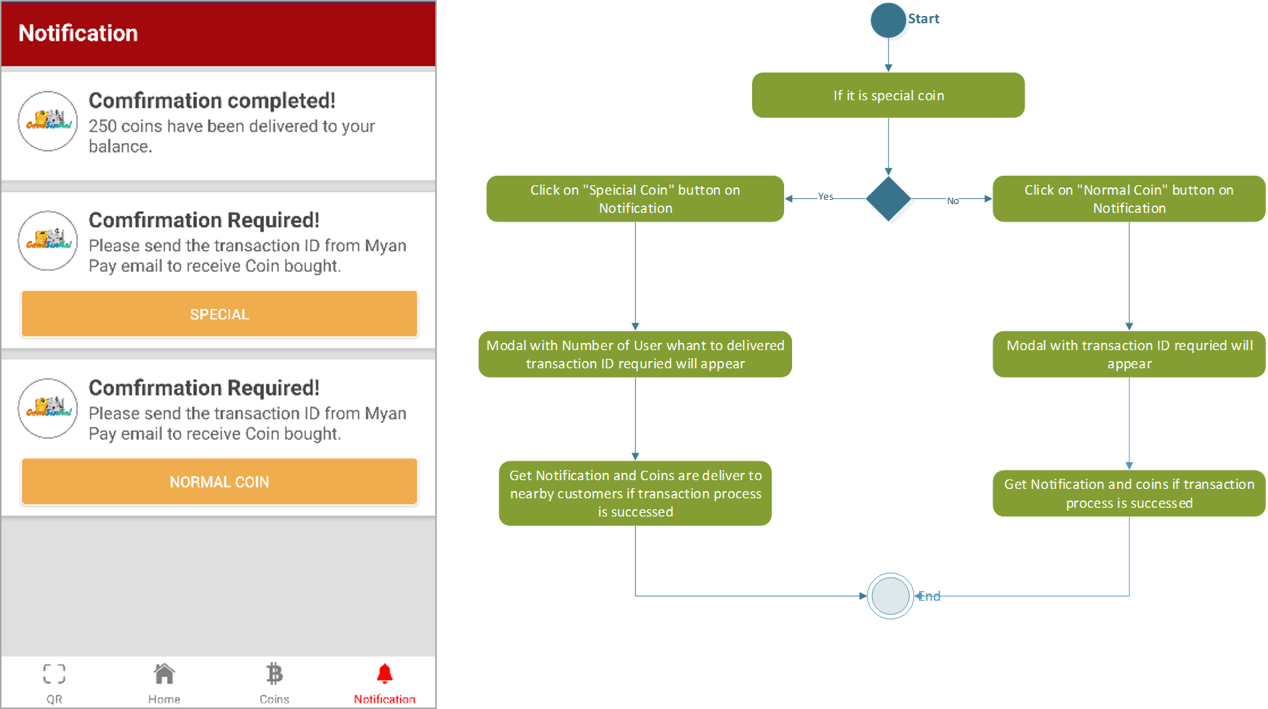

## Administraors

* A page to show an overview of the whole system such as Total Coin sold, special coin sold and coins that are expired. Total restaurants and total customers for the whole system can also be view from this page.

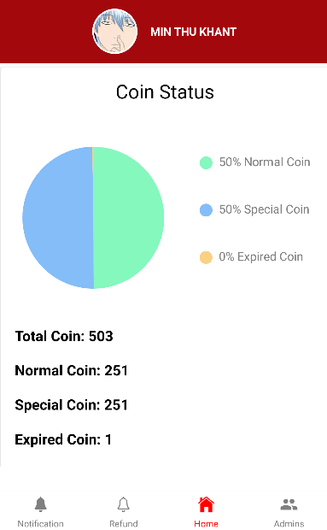

* All coin transition notifications can be view via a separated page this admin side of application.

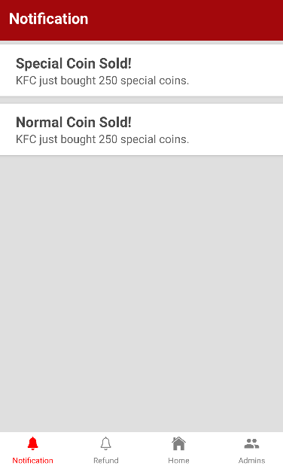

* A section to view Notification of sold-coins and Refund request. Refund request will be handled manually since there is no systematic payment gateway to automate that function in Myanmar yet.

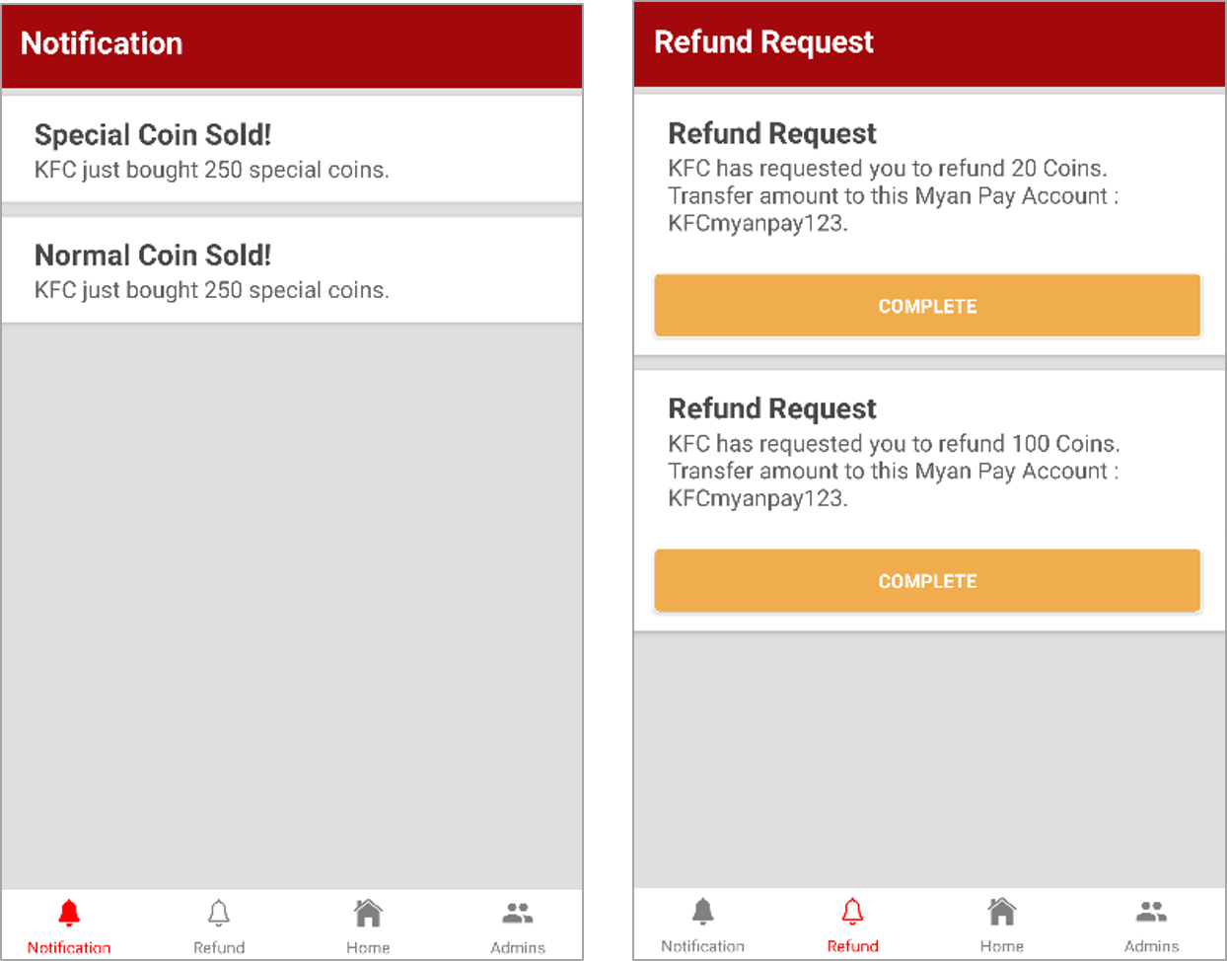



* A page to manage (add or remove) administrator roles.

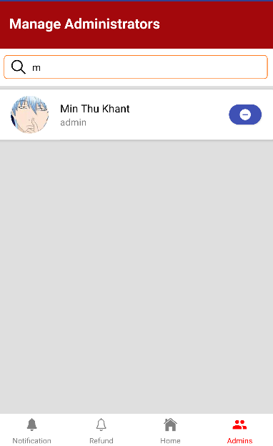

# Success Criteria

The success rate of this application is based on various factors. The primary element which takes part in the application’s success criteria is the total coins in the whole system. The more coins in the system means restaurants are willing to buy coins from the platform owner to promote their sales. The other recognizable influence is the number of restaurants participated in the platform. Even if there is still no noticeable total coin growth in the system, increasing number of restaurants is a sign of potential success. Moreover, number of customers(user) is also be considered as one of the important aspects. As customers are the main reason for the presence of restaurants, there will be no restaurants hosting in this application platform if there are no customers using this application. Therefore, from the business coin of view, even though the growth of coin system seems the most crucial part, the number of customers is in fact the greatest vital in this kind of business. To be conclude, the first priority of success criteria is the number of users, then restaurants and the coin growth. Priority of success criteria can also be organized as follow

* Number of user(customer) in the system - 40%
* Number of restaurants hosted in the system – 35%
* The coin growth in the system – 25%

# Content Plan

As Gone Sin Mal, our application is just a platform, most of the information contents will not be provided by us. Facebook API is used to gain user information and then restaurants information are provided by the restaurants themselves.

# Site Map

## 6.1 Customer Side

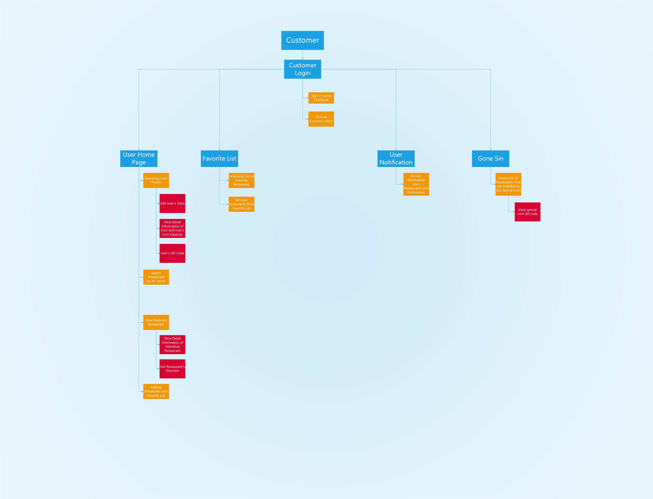

## 6.2 Restaurant Side

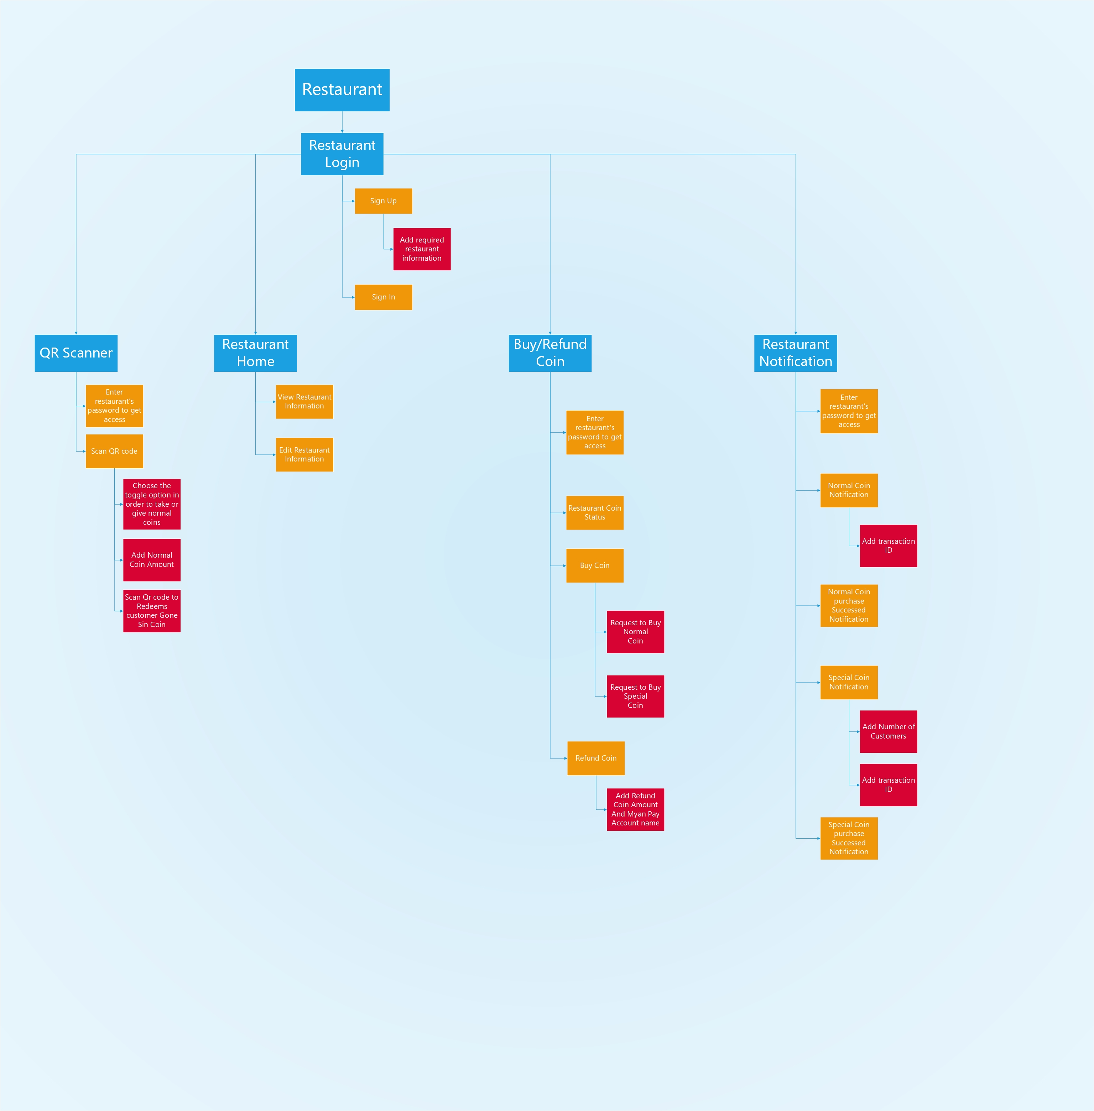

## 6.3 Administrators Side

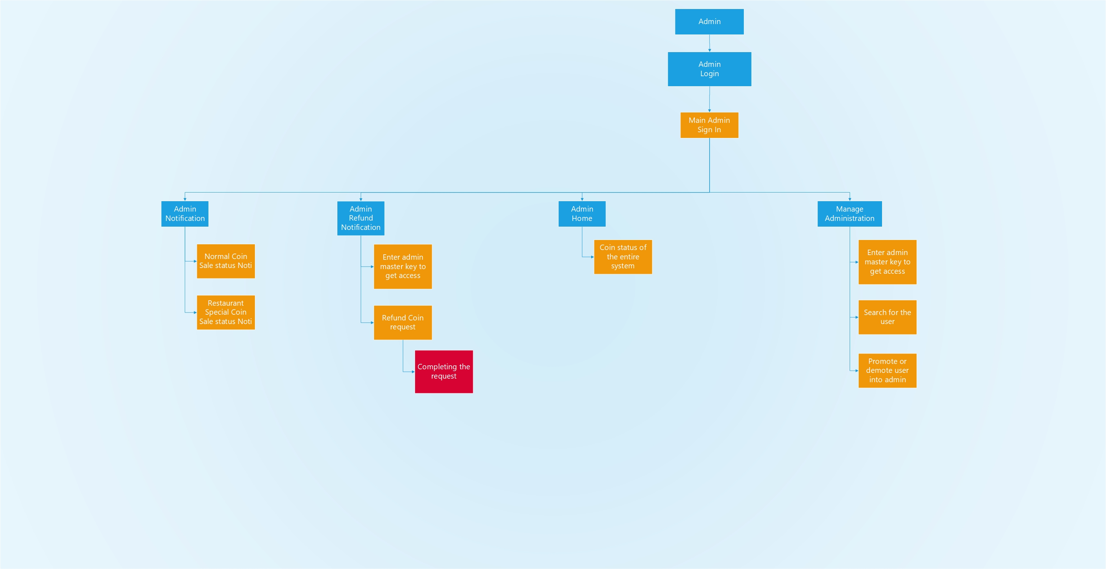

# Marketing Plan

**Universal Currency (Normal Coins):** This application earns profits from selling coins. All restaurants are allowed to host their information with free of charge. Instead, we sell coin packages with only a little amount of profit. Those coins will be delivered to the customers as promotion and then passed on to the other restaurants as the customers use those coins to get discount from other restaurants. In such way, coins will serve as a universal currency. There is also a refund system which allows restaurants to refund the real currency with the coins they have earned from other restaurants.

Let’s assume 1000 coins with 10000 kyats. We have a package which is 10500 kyats for 1000 coins. So we will have 500-kyat profit. However, if 1000 coins were to be refunded, we will refund them with 10000 kyats.

**Special Coins:** a unique currency that can only be used in a specific and it can be used to promote a particular restaurant. If a restaurant wants to promote, it can buy special coins from the platform. The platform will only take a small percentage of special coin package and deliver the coins to the customers who are living near to that restaurant.

Supposing the restaurant buy a 5000-coin package which worth 50000 kyats, unlike the universal coin the platform will only take a percentage (example-10%) which is 5000 kyats. The restaurant will only need to pay 5000 kyats for the whole 50000 kyats worth package.

If so, is buying special coins is more cheap then Universal coin? Buying special coins seems cheaper because the restaurant will have to pay the coins it has bought to promote. Even if all cons are regained and refunded, it will still lose some values. On the other hand, customers tend to love restaurants which give universal coins because it allows them to use the coin for other restaurants. Though giving away coins is the best way to gain popularity, using special coins is the best way to promote the freshly opened restaurants.

**Expired Coins:** the capacity of coins that customer can store is limited to the number of restaurants they have visited. If the coins are exceeding the capacity, the exceeded coins are expired in a certain amount of time. Since this coins are expired away, the coin pool in the system will also decrease and therefore it will also make restaurants to buy more coins from the platform. Moreover, since the maximum capacity is limited by the number of restaurants that customers have visited, it will encourage the customers to visit more restaurants.

# Site Maintenance

Buying coins from restaurant will be automated by Web API and Administrators will be in charge of manually handling the Myanpay transition process for refund since there is no provided API or payment gateway in Myanmar. They will also be monitoring the overview of the system. Providing admins has key to access admin side features, they will have full permission to handle the refund requests and managing admin roles.

# Security For Web Service (API)

**Payment:** There will be no particular security for payment from the app. Transaction security will be handled by MyanPay and security of the Transaction ID in email will be handled by users themselves.

**Non-reusable ID:** Every time user make a Myanpay transaction to the system, the API will track each transaction and record it so that user cannot be the same ID to buy again.

**Admin key and Restaurant Password:** key or password will be asked to access important pages for example: (coins and notification for confirmation pages in restaurants, refund and manage admin roles pages for admins).

**Cross Origin Resource Blocking:** is a mechanism that allows restricted resources on a web page to be requested from another domain outside the domain from which the first resource was served. By customizing this feature, it will only accept the request come from the Application and block all requests from different domains. This will prevent third party attackers to send or consume requests to the API.

# Timeline

For the whole project, we only get less than 7 months. At first, we must form a team to implement Gone sin mal project. Moreover, we need to know their role and responsibilities who join our Gone sin mal project. For project planning phase, the last final stage is to limit the project and its scope. We need to determine the project name, logo of our project. In this case, we only get 5 days to complete these all the stages.

And another phase that is necessary for software development is requirement analysis phase. At first, we must gather information for restaurant that use coin system to develop the idea. And then we need to learn about the functions that can be distinct from similar project. Moreover, we must calculate the coin system that can promote the restaurants. In our Gone sin mal project, there are three side of functions like user, admin and restaurant. So, we must analysis three requirements for the whole project. The last final stage is determining the programming languages for backend and frontend. There are three side of functions, so we need three different user interfaces for the Gone sin mal application. We need to discuss the online payment for Gone sin mal. We must create the Myanpay account. In this case, we will invent the money to Myanpay online payment service. We need more time to implement data descriptions and diagram like class diagram, flow chart, ERD diagram and so on.

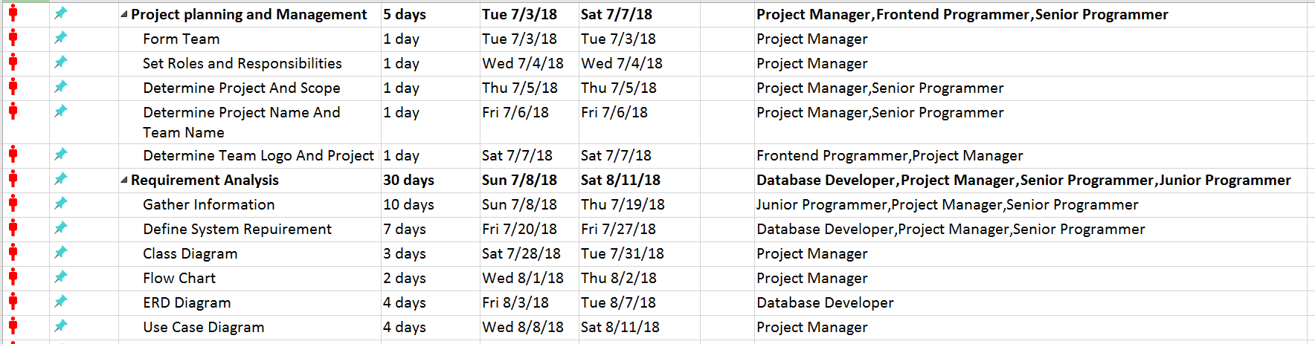

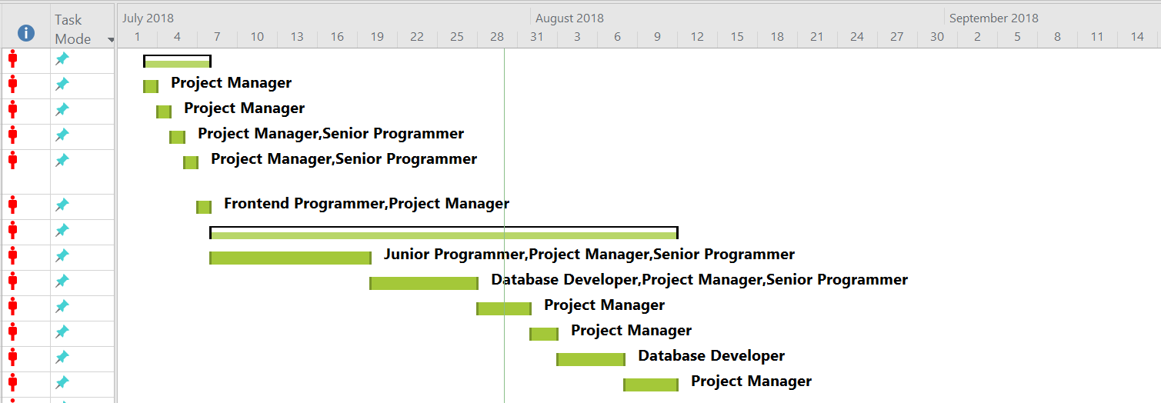

After analyses the requirement for Gone sin mal project. We must implement the user interface design. We have 25 days to development the design phase. First, we will design for customer-side with their functions. And we will design for restaurant-side and admin-side functions. We will also need to integrate the network and database.

In software development phase, codding stage is the necessary stage to develop the project. First, we need to implement to store data. For implementing the database, we only get 5 days to implement. And we need to implement client and server-side functions. We have 30 days to implement these stages.

Testing is the necessary phase for software development. At first, we need black box and white box testing for Gone sin mal. We need to test two side of functions like client and server-side functions. We need to test the security of Gone sin mal application. Because in our project, we must store customer data and restaurant data. And the final thing is user false. We must test the wrong data of user’s data and check the application is still working or not. Testing phase will be started in 10/14/2018 to 11/11/2018 and it duration will be 25 days.

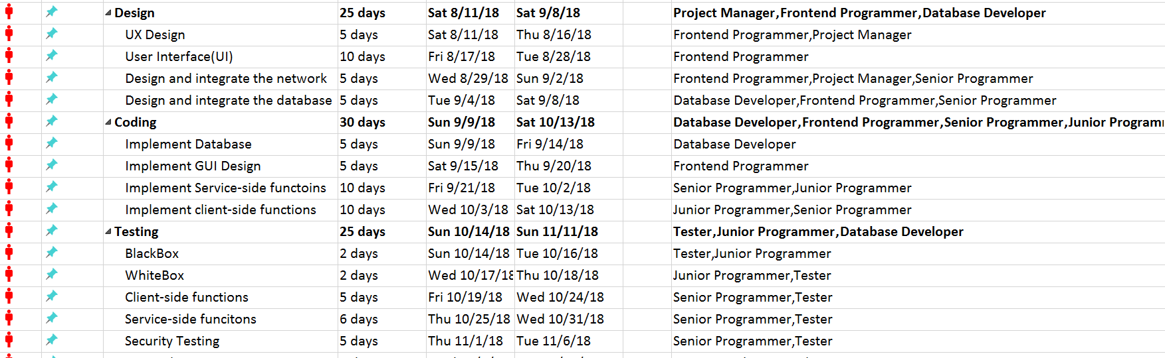

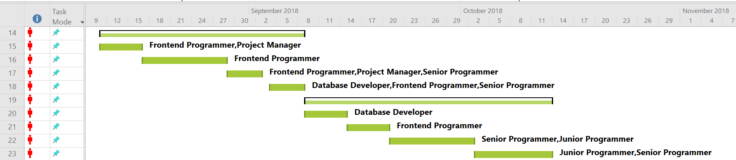

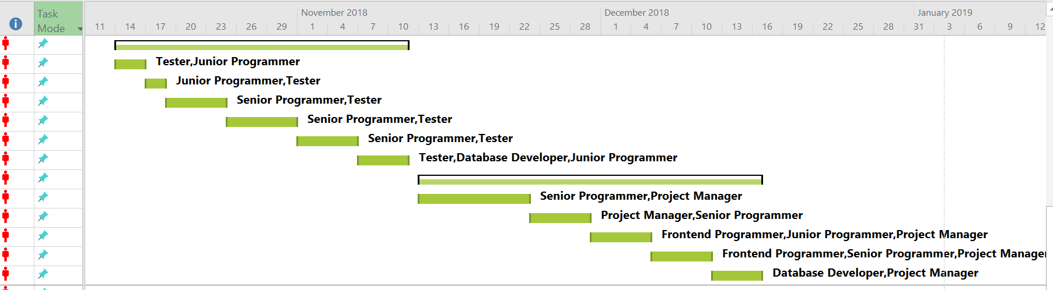

We need to debug the program because when we test the program, it can be getting the error. We need to correct the coding the errors. And then we must remove bug and errors. It will get only 15 days to debug the program. And then we must monitor the project performance and maintenance. It can be another 15 days to debug the program. And the final thing is to train customer. We must create a report user guide and technical guide. It can be 10 days to implement customer support. It starts from 12/8/2018 to 1/3/2018. The final dead line date that must release or submit the project is 1/3/2018.

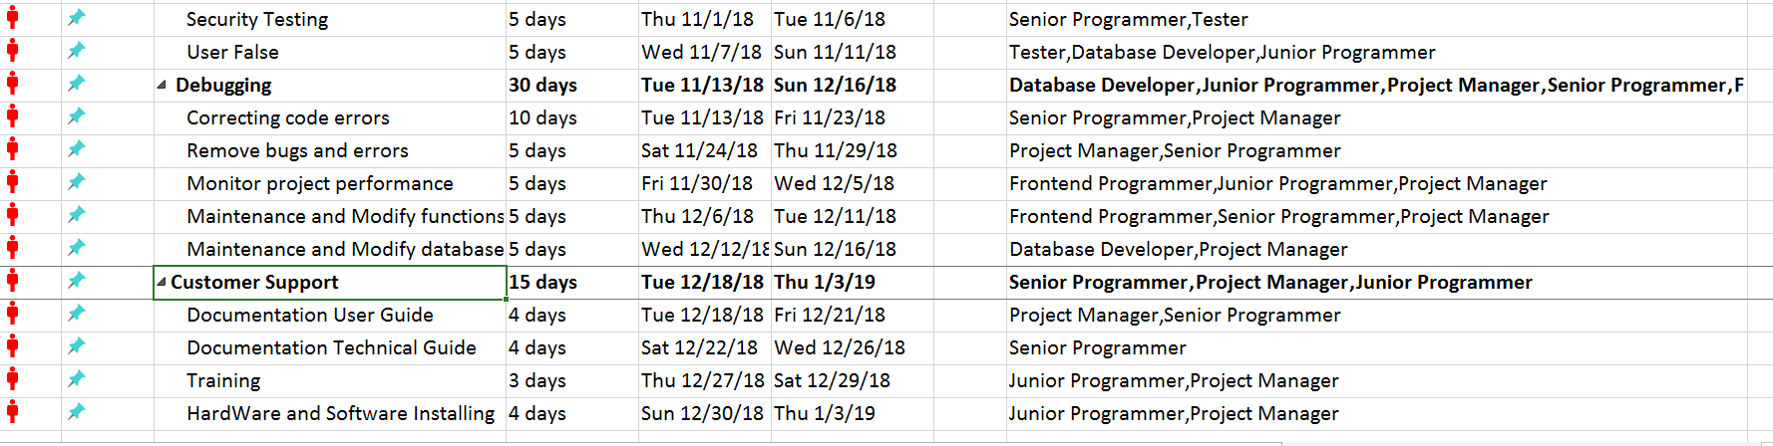

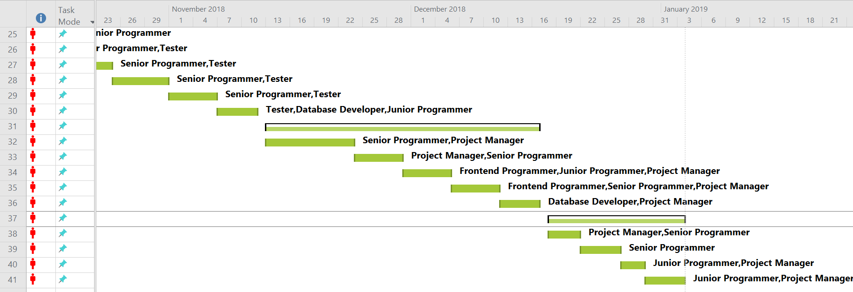

# Technical Information

The following are the technologies which will be required to develop our application.

|  |  |
| --- | --- |
| Application | React-Native |
| Third Party UI Helpers | NativeBase and other open source modules |
| Application API | Asp.net Web API with Entity framework |
| Other API | Facebook API, Google API, LocationIQ (https://us1.locationiq.com) |
| Database | Microsoft SQL |
| IDE | Atom, Visual Studio Code, Visual Studio, SQL Server Management System |